Date | Name & Details | Venue | To Book and More Information |  | Cost & Eligibility
17th Jan | Mastering the Big Three: Pitching, Networking and Business Success | UCS | Mastering the Big Three: Pitching, Networking and Business Success Tickets, Wed 17 Jan 2024 at 12:00 | Eventbrite | 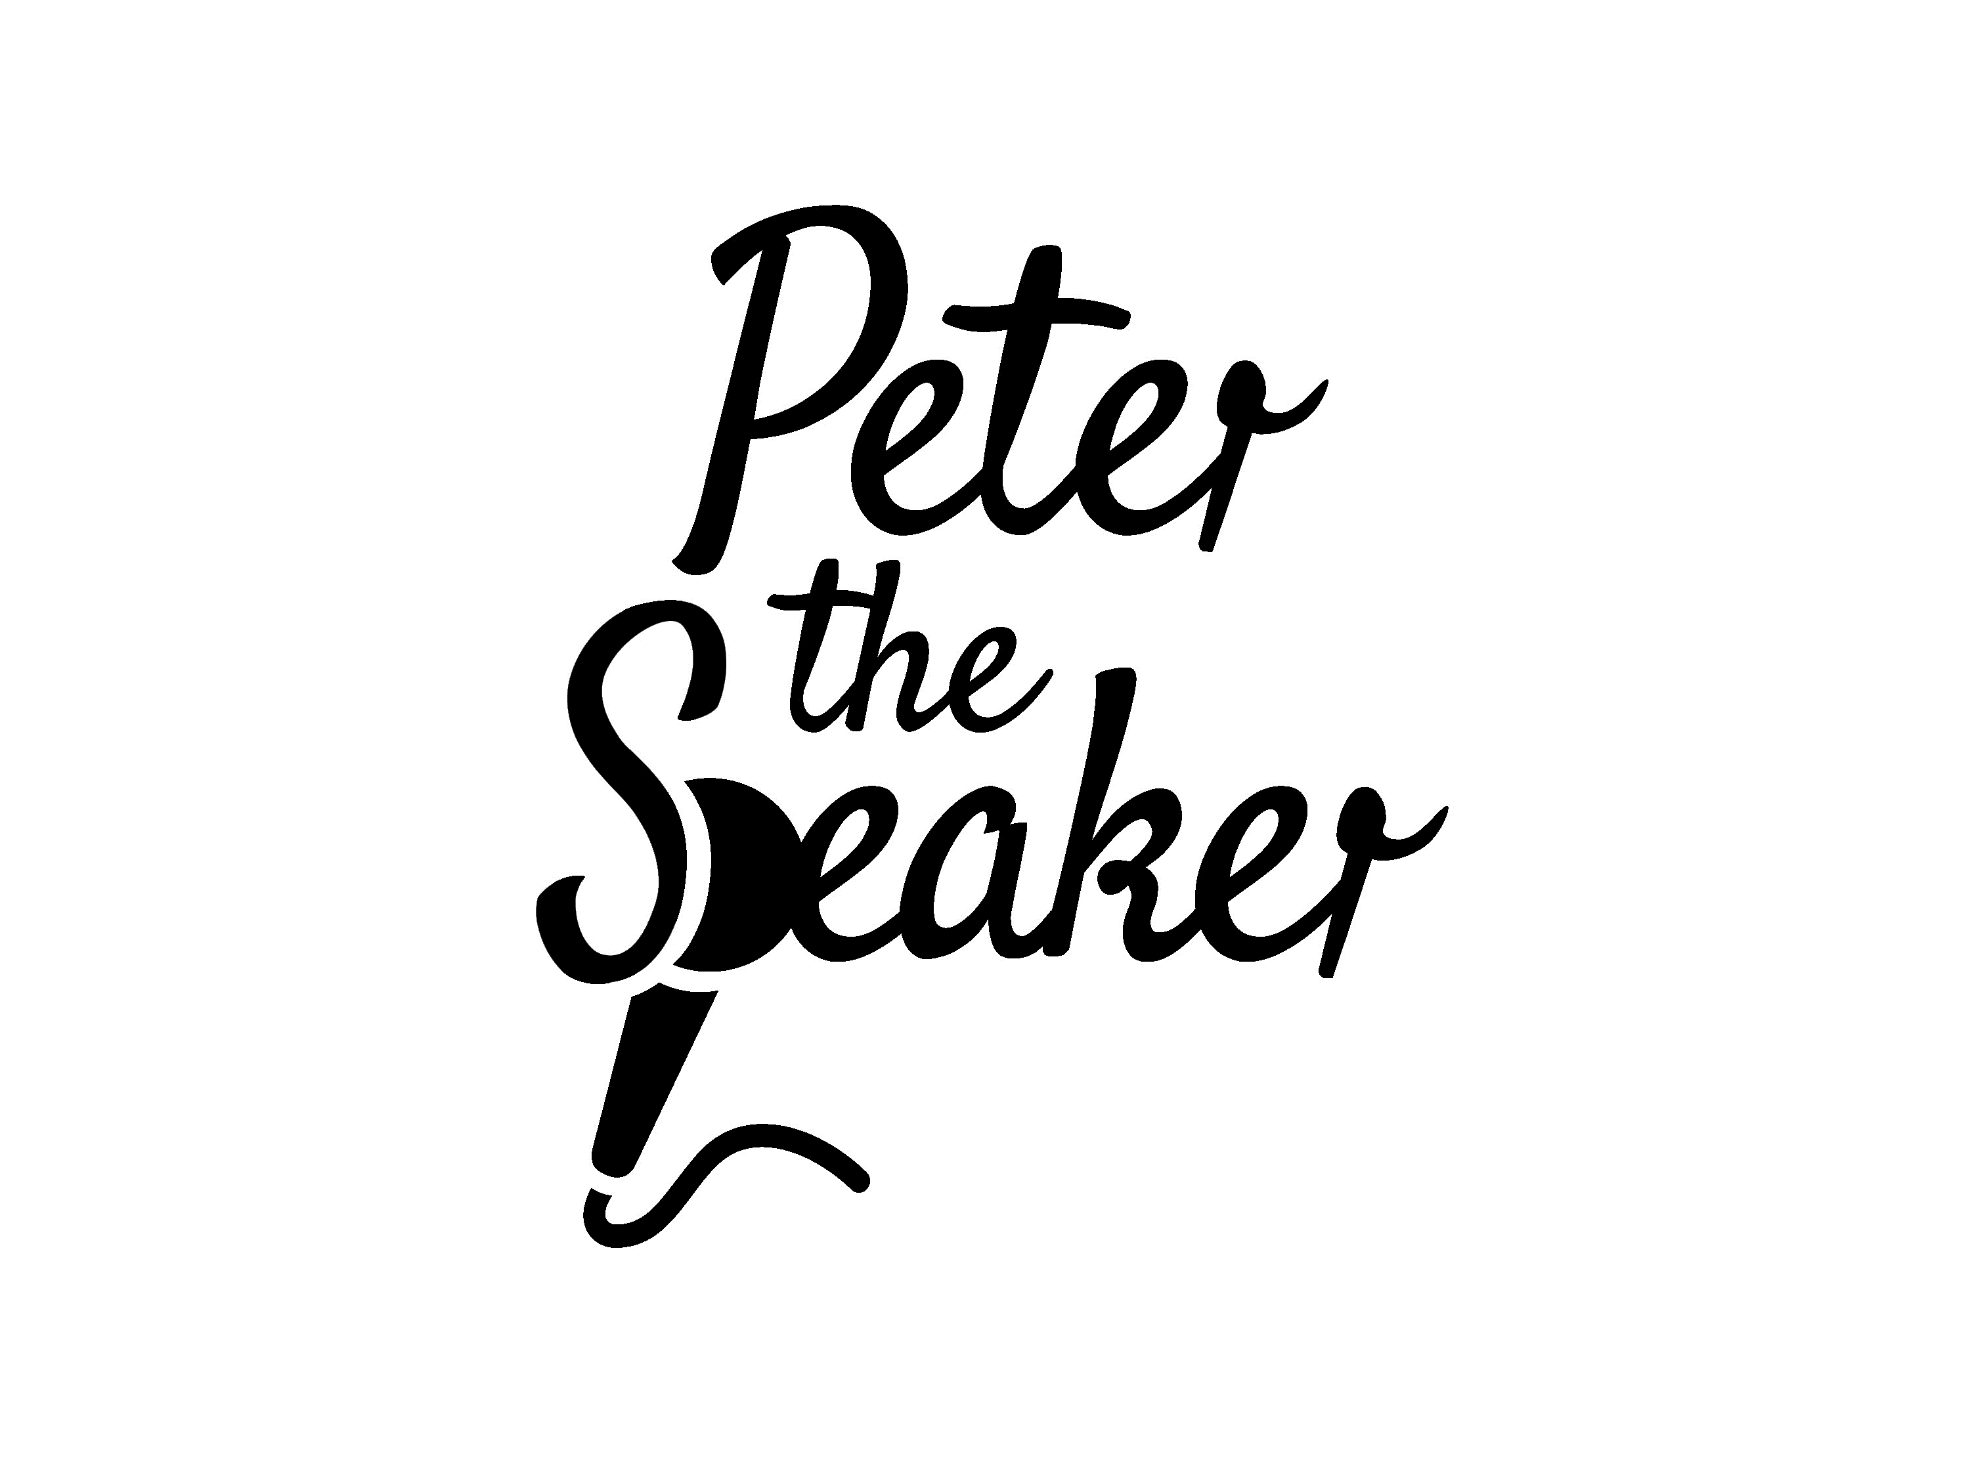 | This event is fully funded and free to businesses based in the Marches area.
24th Jan | How To Get More Business Through Your Use of LinkedIn | UCS | How To Get More Business Through Your Use of LinkedIn Tickets, Wed 24 Jan 2024 at 09:30 | Eventbrite |  | This event is fully funded and free to businesses based in the Shropshire Council area.
30th Jan | Meet the Programme Manager – Shropshire Manufacturing Growth Programme | Marches Growth Hub Shropshire | Meet the Programme Manager - Shropshire Manufacturing Growth Programme Tickets, Shrewsbury | Eventbrite |  | This event is fully funded and free to businesses based in the Shropshire Council area.
31st Jan | From Garage to Glory | UCS | From Garage to Glory Tickets, Wed 31 Jan 2024 at 09:30 | Eventbrite |  | This event is fully funded and free to businesses based in the Marches area.
31st Jan | Learn how to Innovate Your Business Model & Stay Ahead of the Competition | UCS | Learn how to Innovate Your Business Model & Stay Ahead of the Competition Tickets, Wed 31 Jan 2024 at 13:00 | Eventbrite |  | This event is fully funded and free to businesses based in the Marches area.
7th Feb | Instagram for Business | UCS | Instagram for Business Tickets, Wed 7 Feb 2024 at 09:30 | Eventbrite |  | This event is fully funded and free to businesses based in the Marches area.
21st Feb | Marketing Masterclass | Let’s Make 2024 The Best Year Yet! | UCS | Marketing Masterclass | Let’s Make 2024 The Best Year Yet! Tickets, Wed 21 Feb 2024 at 09:30 | Eventbrite | 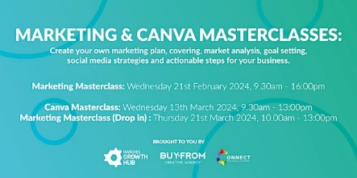 | This event is fully funded and free to businesses based in the Shropshire Council area.
29th Feb | Business Boost in Oswestry | Oswestry Library | Business Boost in Oswestry Tickets, Thu, Feb 29, 2024 at 10:00 AM | Eventbrite |  | This event is fully funded and free to businesses based in the Shropshire Council area.
27th Feb | Capture Your Brand’s Essence: Infusing Your Brand into Your Photography | UCS | Capture Your Brand's Essence: Infusing Your Brand into Your Photography Tickets, Tue 27 Feb 2024 at 09:30 | Eventbrite |  | This event is fully funded and free to businesses based in the Shropshire Council area.
6th March | Grants for Growth | Online | Grants for Growth Tickets, Wed 6 Mar 2024 at 11:00 | Eventbrite |  | This event is fully funded and free to businesses based in the Shropshire Council area.
8th March | International Women’s Day 2024 - Celebrating Shropshire Women In Business | High Grosvenor House  Claverley | International Womens Day 2024 - Celebrating Shropshire Women In Business Tickets, Fri 8 Mar 2024 at 11:45 | Eventbrite |  | Please see Eventbrite listing for costings.  Open to businesses in the Marches.
13th March | Canva Masterclass – Keep your Creative in House | UCS | Canva Masterclass | Keep Your Creative In-House Tickets, Wed 13 Mar 2024 at 09:30 | Eventbrite |  | This event is fully funded and free to businesses based in the Shropshire Council area.
18th March | ChatGPT Hands-On Masterclass | Online | ChatGPT Hands-On Masterclass Tickets, Mon 18 Mar 2024 at 09:30 | Eventbrite |  | This event is fully funded and free to businesses based in the Marches area.
21st March | Marketing Masterclass – Drop-in Session |  | Marketing Masterclass | Drop-in Session Tickets, Thu 21 Mar 2024 at 10:00 | Eventbrite |  | This event is fully funded and free to businesses based in the Shropshire Council area.
Business one-to-ones
 | Business 121 with Matthew Woodhead | Marches Growth Hub Shropshire, Food Enterprise Centre  Vanguard Way  Battlefield  Shrewsbury  SY1 3TG | For current availability - please email the marchesgrowthhub@shropshire.gov.uk for more information. |  | This event is fully funded and free to businesses based in the Shropshire Council area.
 | Business 121 with Shane Stark | Marches Growth Hub Shropshire, Food Enterprise Centre  Vanguard Way  Battlefield  Shrewsbury  SY1 3TG | For current availability - please email the marchesgrowthhub@shropshire.gov.uk for more information. |  | This event is fully funded and free to businesses based in the Shropshire Council area.
 | Marketing Advice Sessions with Louise Welsby | Various | For current availability - please email the marchesgrowthhub@shropshire.gov.uk for more information. |  | This event is fully funded and free to businesses based in the Shropshire Council area.
Friday Hub – mini business masterclass and networking event

Weekly, every Friday (not including bank holidays) | Friday Hub – virtual event  A collaborative space to meet others and find practical solutions to support your business... | Zoom | https://bit.ly/G2G1FriHub | 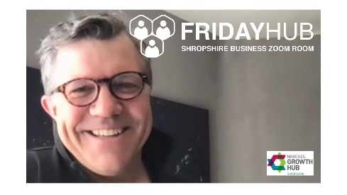 | Free to eligible businesses
Let’s Do Business in…
2024  10-14.00  Market Drayton 12th March 2024  Ludlow 9th April 2024  Bridgnorth 30th April  Shifnal 7th June |  | Your local library | The Marches Growth Hub Shropshire in collaboration with Shropshire Libraries is coming to a town near you in 2022. The aim is to make it easier for businesses to access support services.  The team can offer advice and support to businesses and entrepreneurs looking to establish a new venture, or grow an existing business.  Why not pop along to the library to meet representatives of your local business support community?  This is a ‘drop in’ event, no appointment necessary.  Ready to talk business over coffee & cake!  For more information, please email marchesgrowthhub@shropshire.gov.uk | 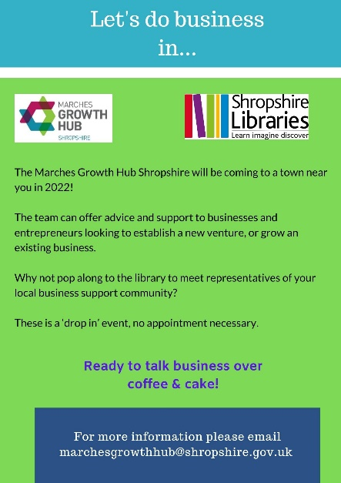 | Free to eligible businesses  (Shropshire Council Area Only)

